Programming in PI Web API Final Project

Andy Egelhof, TEC Systems Group Inc. 7/10/2019

[aegelhof@tecsystemsgroup.com](mailto:aegelhof@tecsystemsgroup.com)

**Intro:** This is a demo project using a development server, that meets the requirements but not using production data. This is a webpage running in dot net core.

**Usage:** There are two main areas of the website. **AF Element Search** and **Create PI Tag**.

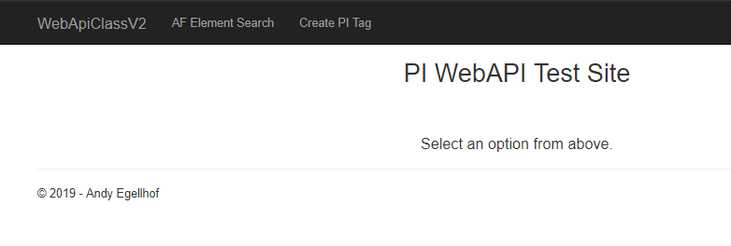

**AF Element Search**: Allows you to search a data for an element by name, select an attribute from that element and trend it. It also allows you to adjust the Start and End times of the trend. This uses the AF Element Search and streams capabilities of PI WebAPI.

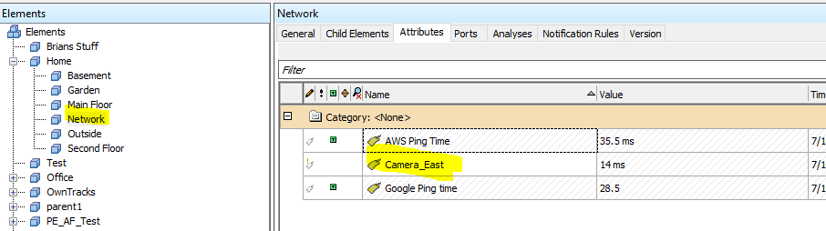

|  |  |
| --- | --- |
|  |  |
|  |  |

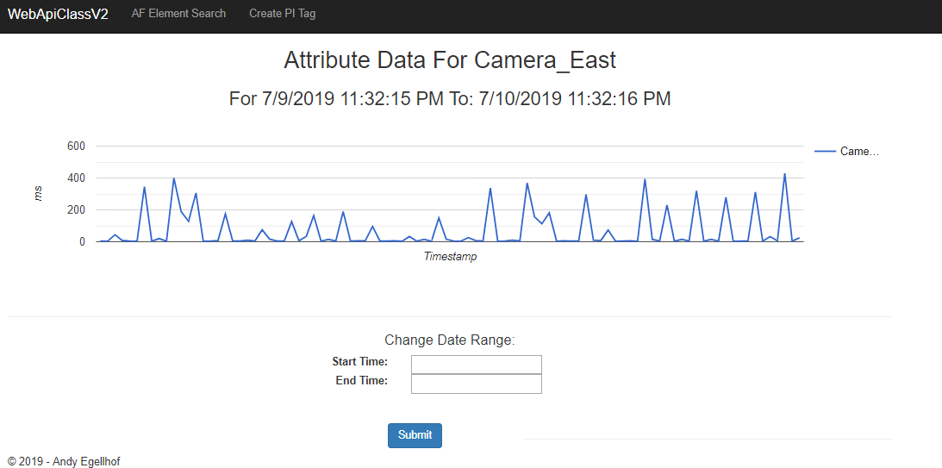

Changing Start, End Times

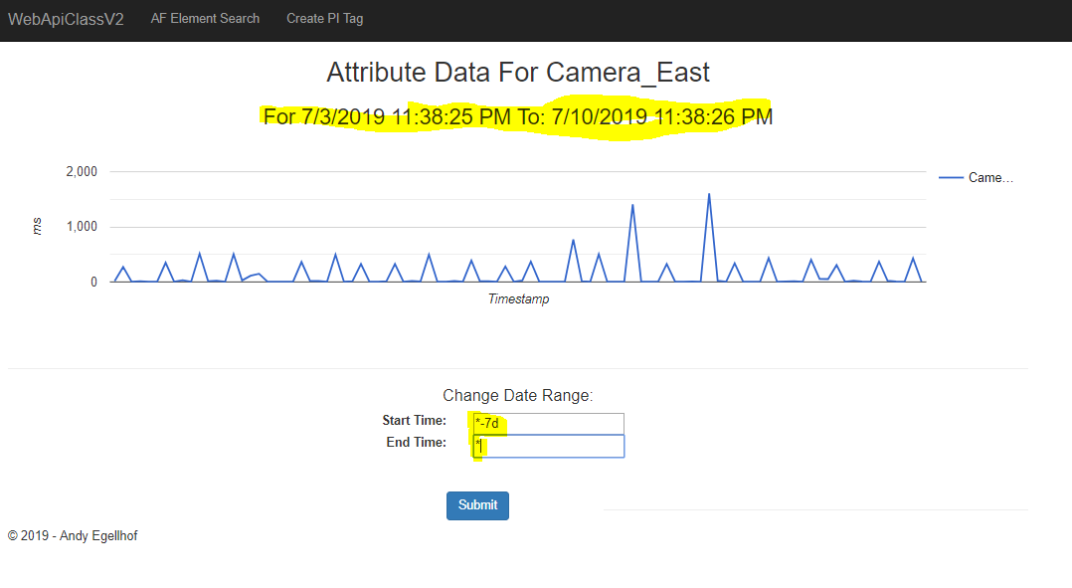

**Create PI Tag**: This function creates a PI Tag, sets a value and updates the description based on form values entered. This uses the Batch controller as well as the GET, POST and PATCH verbs of the PI WebAPI.



    
    
    